Abstract

For over 15 years Games World provides with unique opportunity to all gamers around the world to download and play 5000+ games at fair prices.

**Created By**

**Fahim Ahmed**

**Taharam Chowdhury**

**Lamyea Hoque**

**Akil Adnan Bhuiyan**

Games World

Online Games Store

Games World

“Games World”” is an online games store which sells latest and old PC games. All our downloadable games are full version with secure downloads, no trial periods and no ads. Download as many games as you want play as long as you want, you will be never charged for anything.

"There is no way to succeed in business without the highest ethical standards"

– Jordan Belfort.

As an online business, very important thing here we follows is the **transparency**. To make a good bond between company and client, we have provided the company profile regarding the 15 years of history. And also, the company contact details.

Well use of well secured internal system to improve the **integrity** of the data and calculations for the items and prices for the orders. Websites **secure the customer data** by applying the techniques and make lawful interconnection.

We are providing PC games above +5 years old ages who owned computers and people who sell PC games locally and the people who owned game cafes.

We provide latest and old pc games which people loves to play. And we allow them to buy the Full Version of the game. The activation for the game will be available for any number of users and for lifetime. In future we will allow them to have good discounts and offers.

There is nothing deep to research regarding the gaming field. But the customer needs to have a look around the system requirements which required for each game. They need to check their computer has enough performance to run the game.

Targeted users have good knowledge around the gaming field. Computer games are something that many people do as a hobby since several decades.



The prices of the games can be changed according to the time. And new games can be released each and every day. So, the customers need to be updated regarding that.

If they wish to buy a game, they can search more regarding the game in the official site of the particular game. Game story, System requirements, Credits, View of the game and etc. are the information that users have to discover as they needed.

Video Game Companies

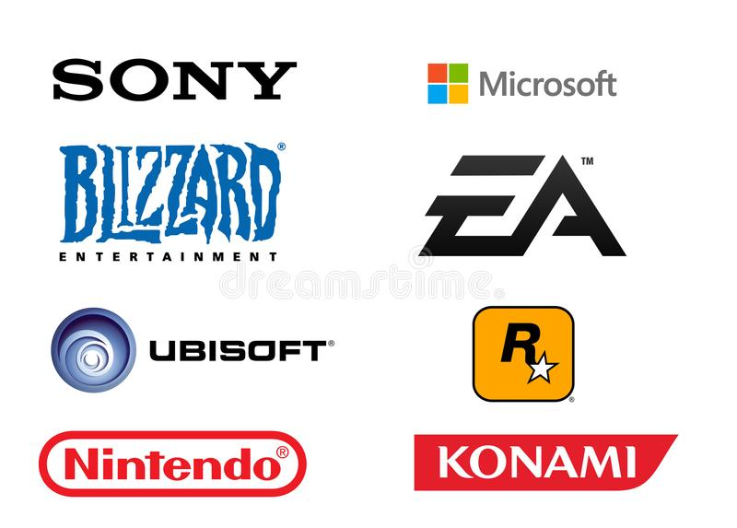

Our site has provided Email, Contact Number, Address, and map locations. Customers can contact the company anytime within Monday to Saturday from 8.00 am – 8.00 pm. Or make an appointment through an email to meet our team.

This is a field which close to the people since the Personal Computer invented. So, there is no any effort need to make it familiar for our clients.

As a product, each game has unique information. So, the customer needs to have a look around the product before they buy.

Customer can add games into cart and check the cart and provide contact information. Then they can get the download link for the game to their provided email address.

Hierarchy of the website

HOME

Check Out

Products

Find Us

Gallery

Many sites provide free versions of the games, and we need to make the payment separately. Here we provide them online payment and they can directly download the paid full version easily.

The people who interested in the gaming field are very much familiar to ask the next versions of the game. And they are also familiar to ask the new versions of the old games that they have played in their childhood.